|  |
| --- |
| [Company name] |
| CAB 302 Assignment 2 |
| Group 108 |

|  |
| --- |
| Timothy Melville (n8856508) & Dean McHugh (n9656286)  Semester 1, 2018 |

# Program Architecture

## Objects

The objects package contains classes related to objects used at a store level.

### Item

The item class is used to create Item objects. Items are used to depict each Item sold by the store, each having a name, price (Both for selling and buying), a re-order point, and a re-order amount. Optionally, an Item may have a maximum temperature it may be stored at. To accommodate for this, the Item class has an overloaded constructor that contains the additional temperature argument.   
The Item class also implements the Comparable class, allowing Items to be compared against each other so they may be sorted, by both name and temperature.  
The class otherwise contains a series of getter methods for Item properties.

### Stock

The Stock class depicts a Stock object used to contain a number of Items. This class extends the Iterable class, to be able to utilise for each loops for Items within a Stock object. Items are stored as keys within a TreeMap object, with quantities of Items stored as corresponding values. Using a TreeMap object allowed simple addition or removal of items and modification of quantities, as well as ensuring the Items contained would be consistently ordered. The class also contains getter methods for items, quantity, and the minimum temperature of contained Items.

### Store

The Store class implemented a Singleton pattern, allowing only one instance of the object. The Store contains two Stock objects, one representing inventory, and the other representing an order list to be used in creating an order manifest, as well as a double representing the Store’s capital, and a String representing its name. The class contains getter methods for Store properties, as well as methods for adding and selling items to/from the inventory. A final method, reduceCapital is used when a manifest is received by the Store, as the Store is charged for both Stock and delivery.

The Store’s capital is never rounded, but when accessed via getter method the returned value is rounded to two decimal places.

## Delivery

The Delivery class contains classes related to delivery of Stock and Items to the Store.

### Truck

The truck class is an abstract class that defines the basic structure of both OrdinaryTrucks and RefrigeratedTrucks. As it is extended by both OrdinaryTruck and RefrigeratedTruck to create different objects based on the same principles, it is an example of polymorphism. All methods besides the constructor and getter method for contents are abstract as they are implemented differently in each extension. Trucks as a whole have a cost, a maximum number of items permitted, and a type.

### OrdinaryTruck & RefrigeratedTruck

Both the OrdinaryTruck class extends the Truck class with different methods for determining cost and setting/getting temperatures. In particular, the ordinary truck throws an exception if the getter method for temperature is called.

### Manifest

The manifest object is used as a collection of Truck objects. It implements the Iterable class to allow for each loops of Trucks within a Manifest. An ArrayList is used to store Trucks, as it is re-sizable, elements inside can be accessed non-sequentially, and implementing the Iterable method ‘iterator’ is trivial. The manifest has two constructors, each for use in different scenarios. The first constructor with no arguments is for use by the CSVRead class, when Trucks are read and sequentially added to the manifest. The overloaded constructor with a Stock argument is used by the Store class, where an order list Stock object is used to create a Manifest, with the manifest automatically determining the best configuration of Trucks to use. The manifest object also contains a cost determined by the types of trucks and Items stored within each Truck.

## CSV

Both classes within the CSV package contain only static methods and variables, as neither class constructs an object. These classes are used for the reading and writing of CSV files at a pre-determined filepath.

### FileRead

The FileRead class is used for reading three separate files with different file structures, and as such, there are three public methods, each for a different file, and each returning a different object. The method used for reading sales logs increments a class-wide counter every time it is called in order to properly move through the sales log files.

### FileWrite

The FileWrite class contains methods only to be used for writing the manifest.csv file, and as such contains only one publicly-accessible method, using a manifest as an argument. The class, using a private helper method writes Trucks and the contents of each truck to file as necessary.

## Exceptions

Each exception class is functionally identical, each extending the Exception class, and overriding the default constructor, and constructor with a String message argument. The use of three exception classes with identical functionality means less generic exceptions are thrown, and the cause of the error can be found much more easily. The three exception classes used are:

### StockException

### DeliveryException

### CSVFormatException

## GUI

### EntryPoint

The EntryPoint class has the main method which starts the program by creating an instance of the store and naming the store. The main method then creates the GUI to control the back-end operations. These operations are contained in four public methods to import item properties, export manifest, import manifest and import sales logs. These methods achieve this by calling methods in the csv, delivery and objects packages.

### GUI

The GUI class has private methods that create a GUI interface accessed by the public run method. The GUI class has a main GUI creator method that initialises the components used inside the JFrame. This is achieved with the use of helper classes to create JTable, DefaultTableModel, JScrollPane, JTabbedPane, JPanel, JTextArea, JButton, and JLabel. The stock table was created by iteration through the store inventory list and calling getter methods to get each items property. This table is then updated whenever the inventory is changed with the newTable method. The main functionality of this class is in the public actionPerformed method. It activated on each button clicked and determines which button is pressed. If the item properties button is clicked then the EntryPoint importItemProperties method is called. If the import manifest button is clicked the EntryPoint importManifest method is called. If the export manifest button is clicked the EntryPoint exportManifest methos is called. If import sales button is pressed the EntryPoint importSales method is called and if capital button is clicked the messages box shows the current shop capital. All button events are wrapped in exception try pass and handled but showing a message box with the type of exception shown to the user.

# GUI Testing

The GUI interface was implemented using the swing GUI widget toolkit. The testing of the GUI was conducted to test all functionality specified in the assignment outline. The testing required the GUI to handle all exceptions thrown by the back-end and present them in message boxes.

## Viewing store capital

The GUI must show the store capital after the capital button is clicked. After clicking the capital button, the current capital is shown in the message box at the bottom of the GUI interface.

Testing this function was conducted buy clicking the capital button at the start of the program before importing any Item properties, manifests or sales. The capital button was then clicked after importing a combination of manifests and sales to show a reduced capital according to Items added or sold from store inventory.

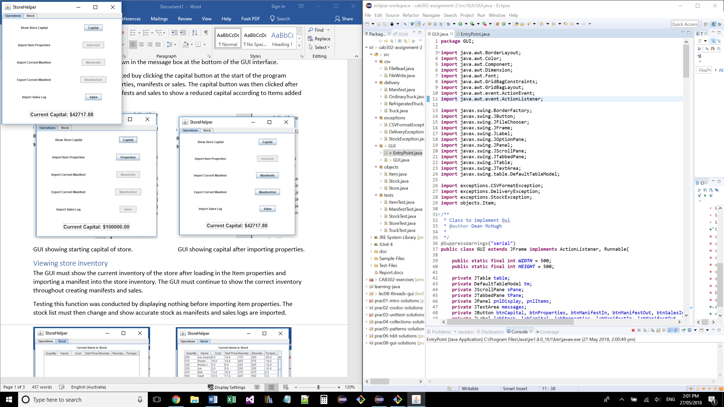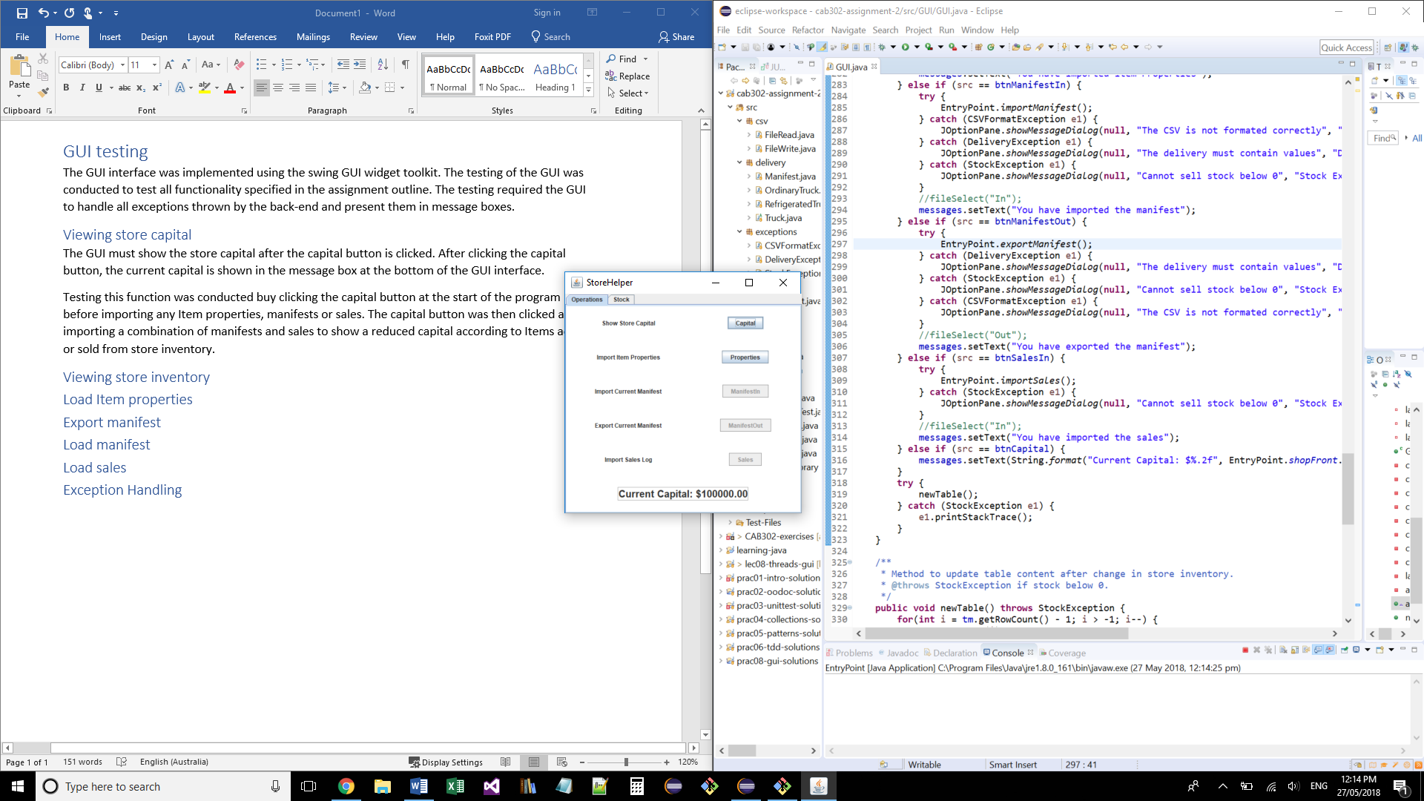

GUI showing starting capital of store. GUI showing capital after importing properties.

## Viewing store inventory

The GUI must show the current inventory of the store after loading in the Item properties and importing a manifest into the store inventory. The GUI must continue to show the correct inventory throughout creating manifests and sales.

Testing this function was conducted by displaying nothing before importing item properties. The stock list must then change and show accurate stock as manifests and sales logs are imported.

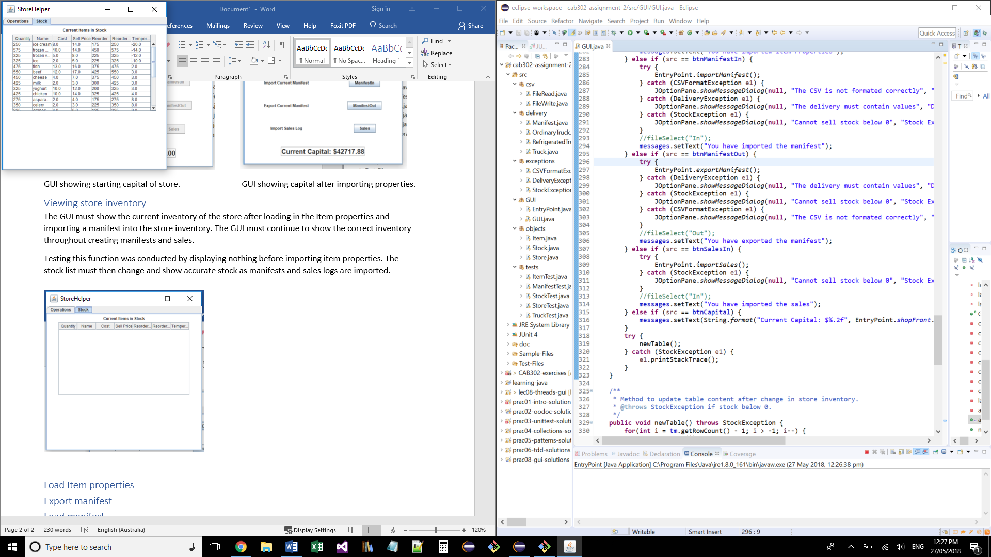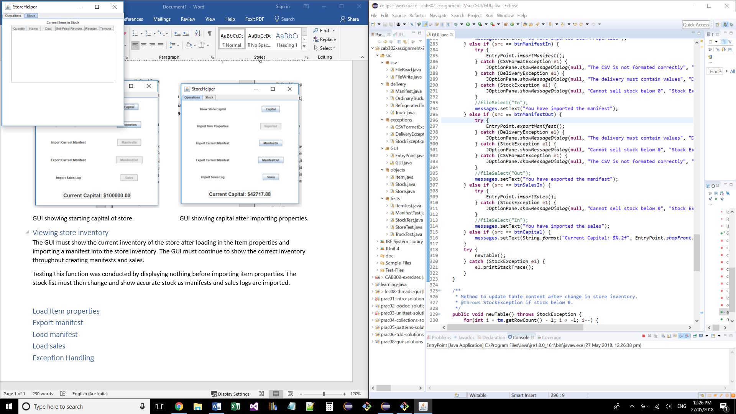

Stock list before importing item properties Stock list after importing item properties

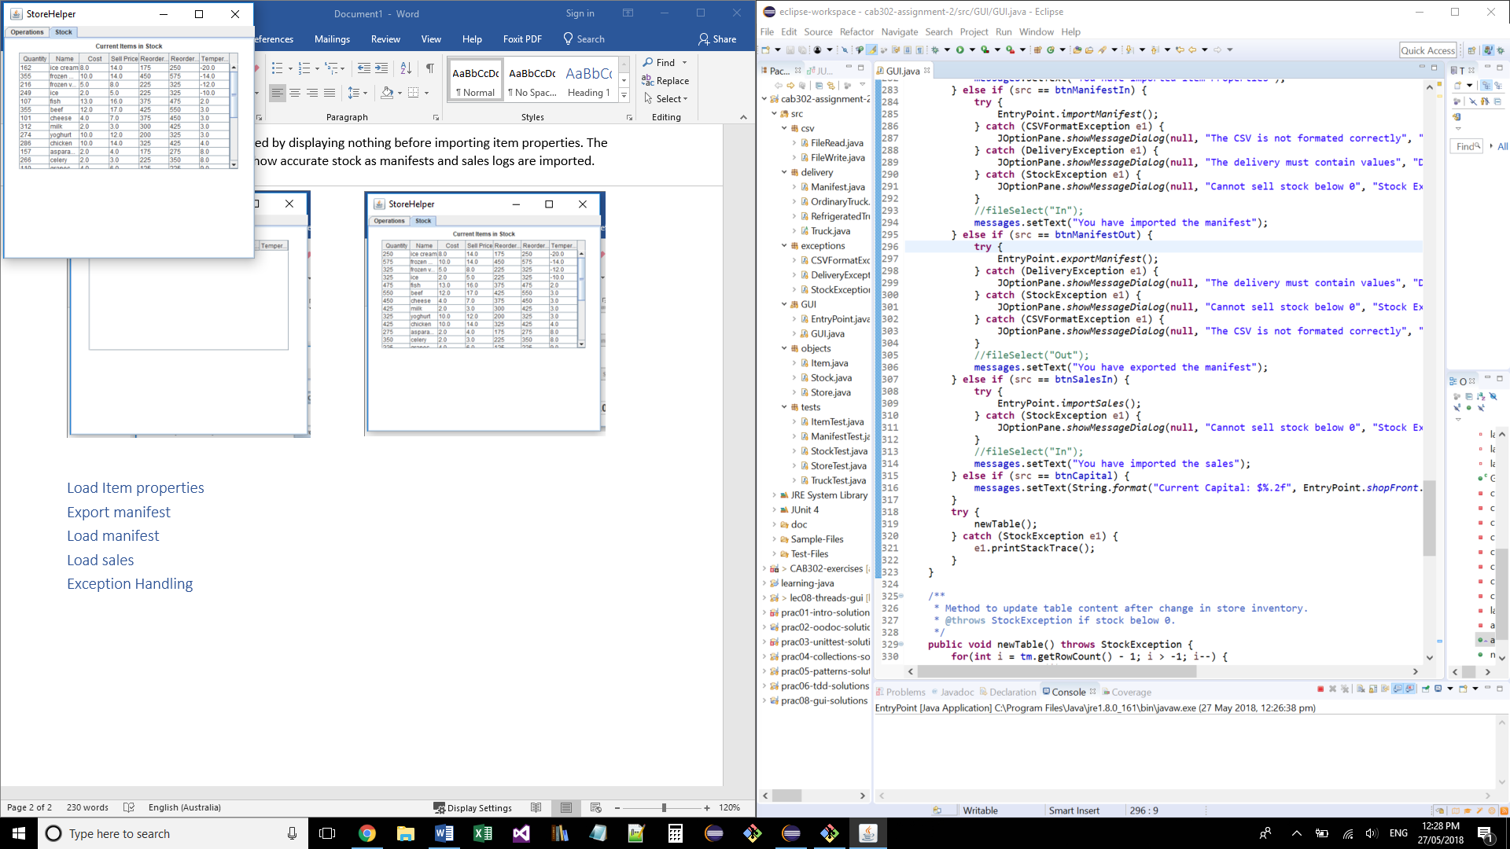

Stock list after importing a sales log.

## Load Item properties

The GUI must import Item properties after clicking the Item properties button. This will also trigger the export and import of a manifest to stock the store inventory with each item. Clicking the import item properties button will activate the sales button. Clicking the item properties button with disable the button as this only needs to be done once.

The testing of this function was done by observing the change in the stock list. Before clicking the Item properties button the stock list was empty. After clicking the item properties button the stock list must be populated with the stock in the store inventory. Clicking the item properties button observed the activation of the sales button and disabling of item property button.

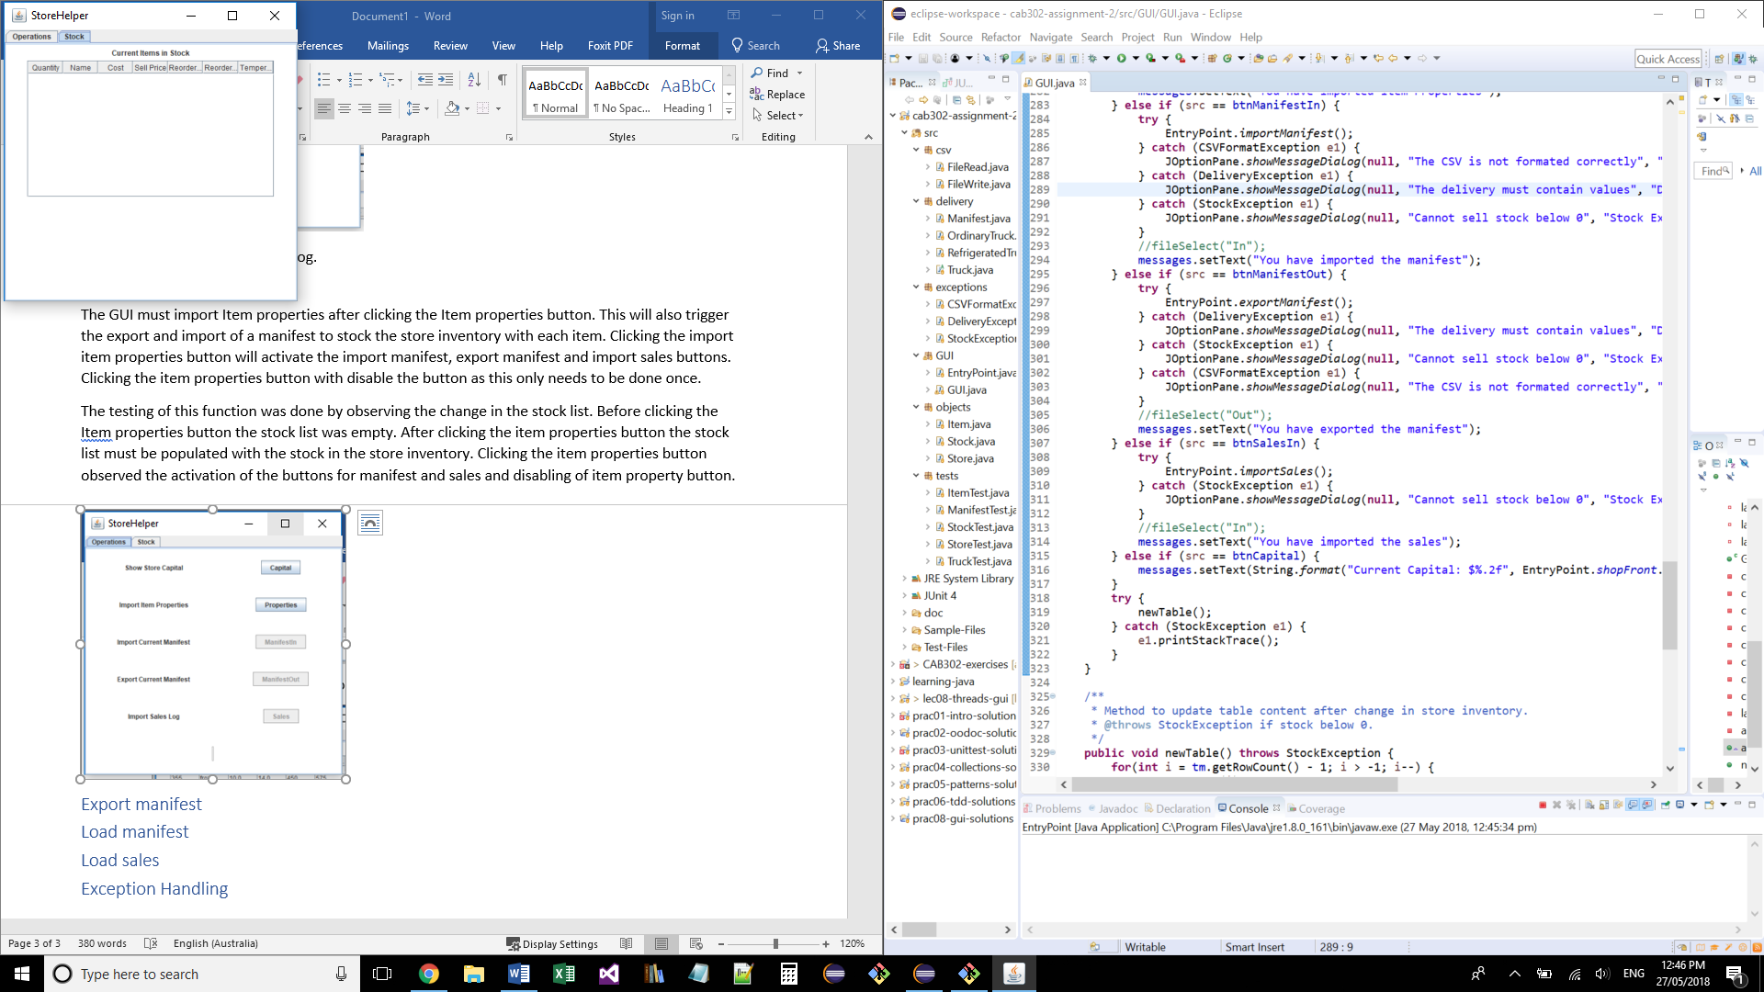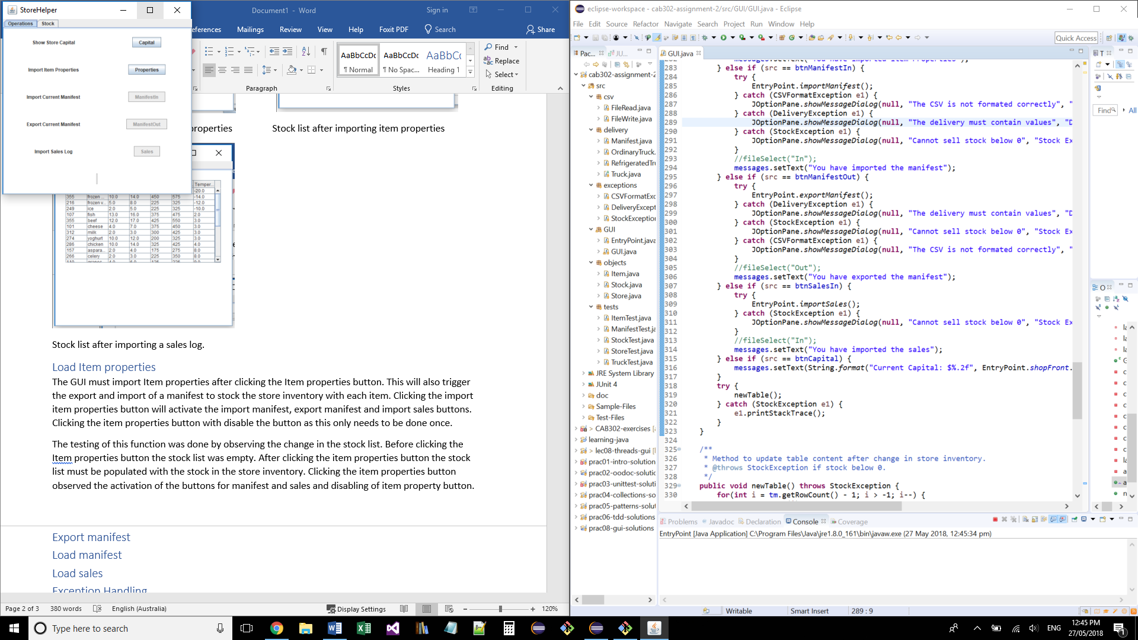

Before clicking: The GUI manifest buttons and sales button are disables and the stock list is empty.

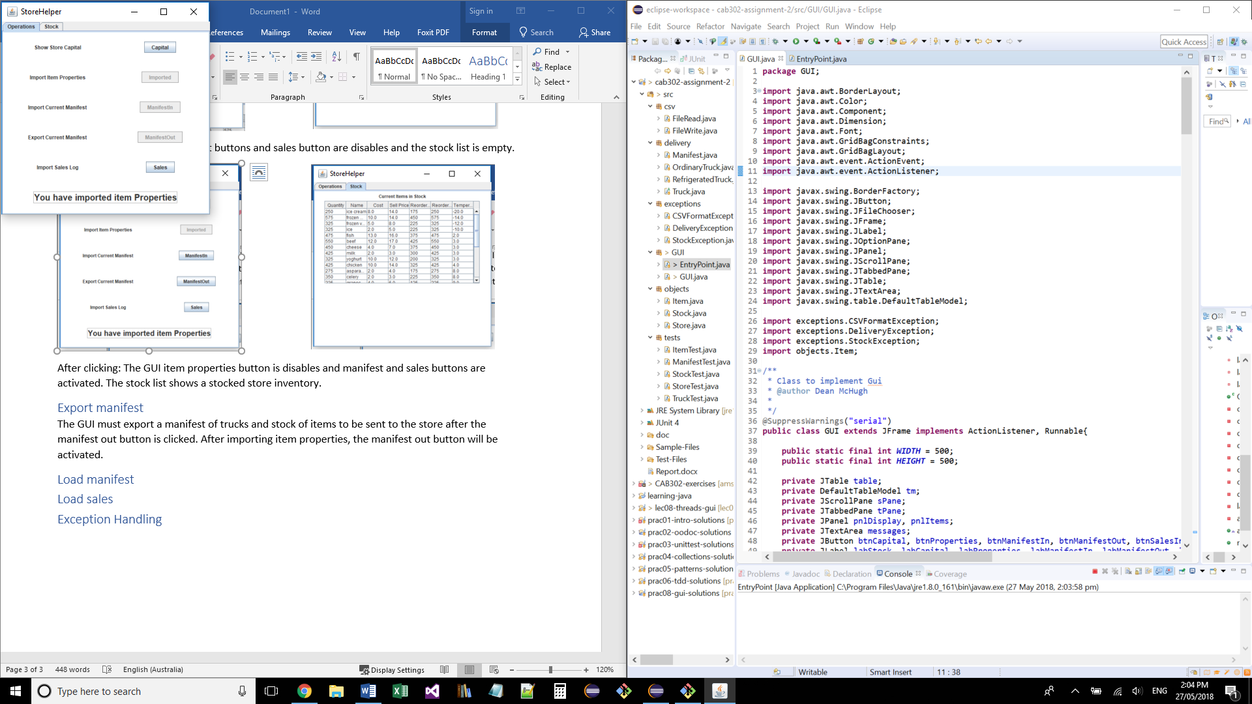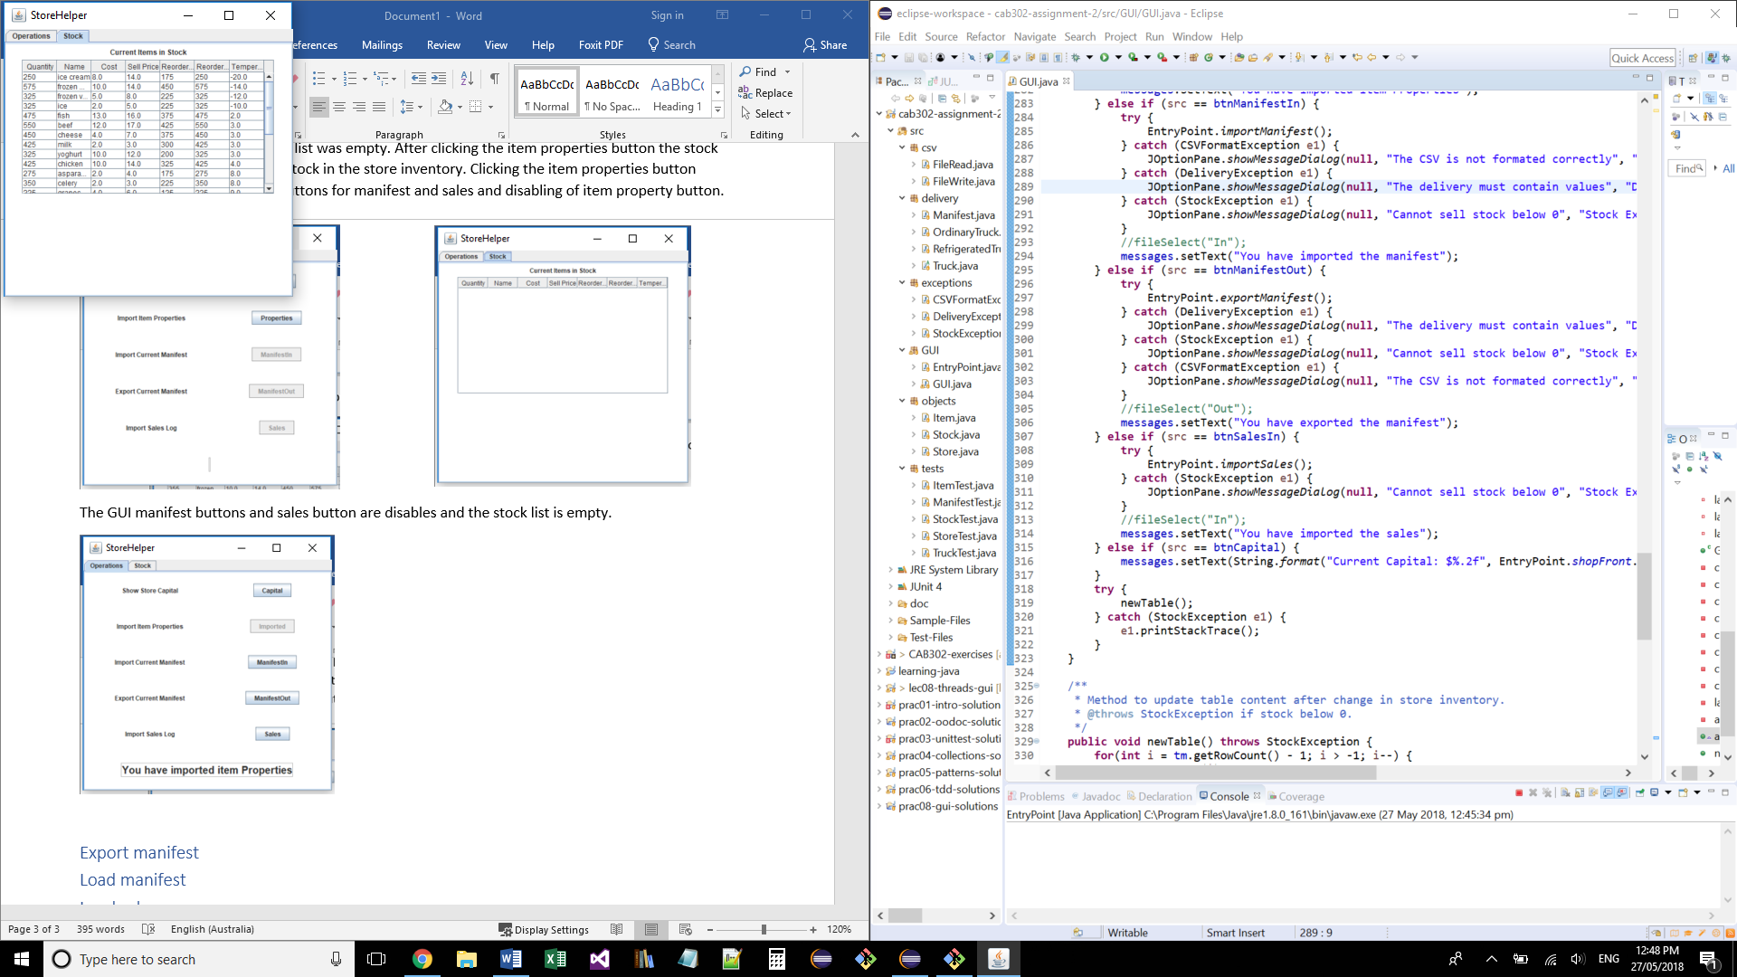

After clicking: The GUI item properties button is disables and the sales button is activated. The stock list shows a stocked store inventory.

## Load sales

The GUI must import sales logs after the sales button is clicked. This will remove the items from the store inventory and add the sell price to the store capital. Clicking the sales button will activate the manifest out button and disable the sales button.

Testing this function was dose by watching the change in stock list and inventory as the items are sold. This was shown with the sales button being disabled on click and manifest out button activated.

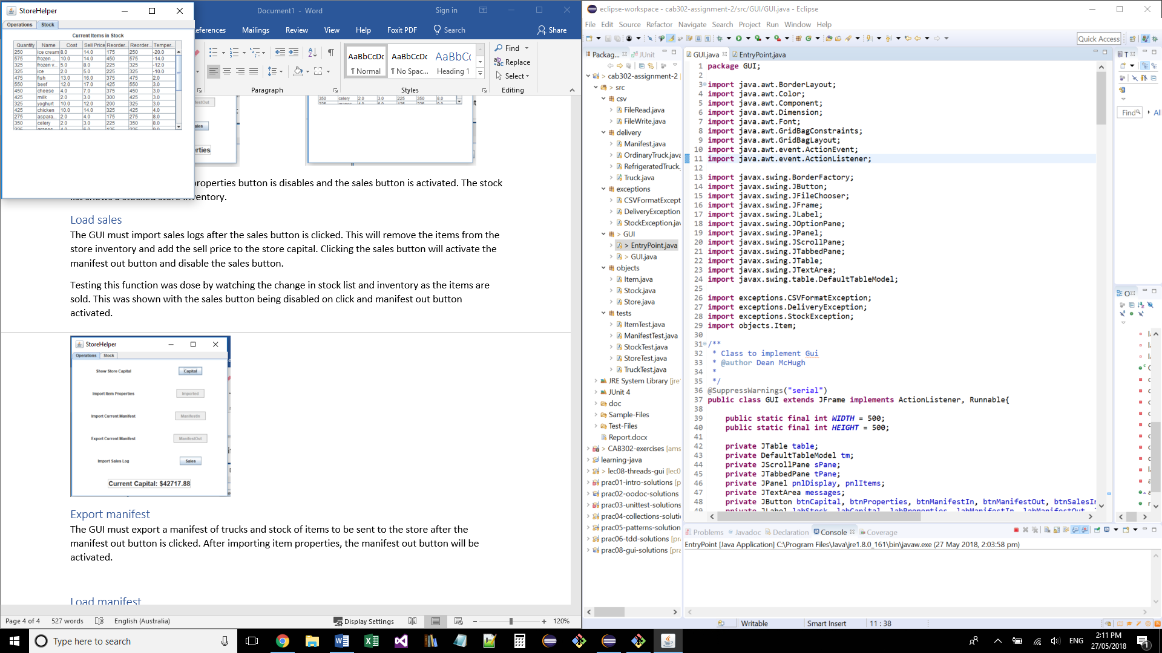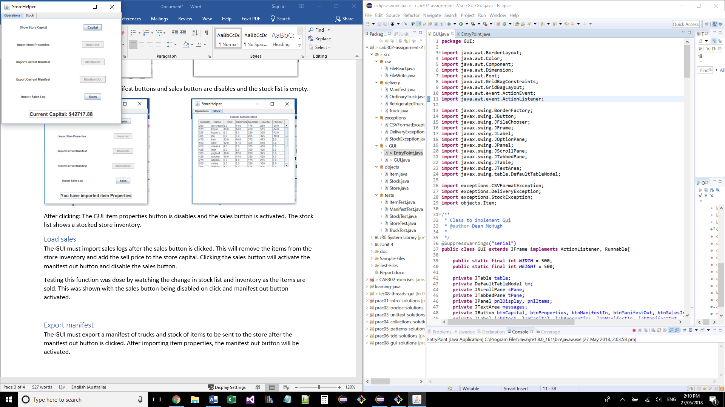

Before clicking: Store capital is shown and the store inventory is fully stocked.

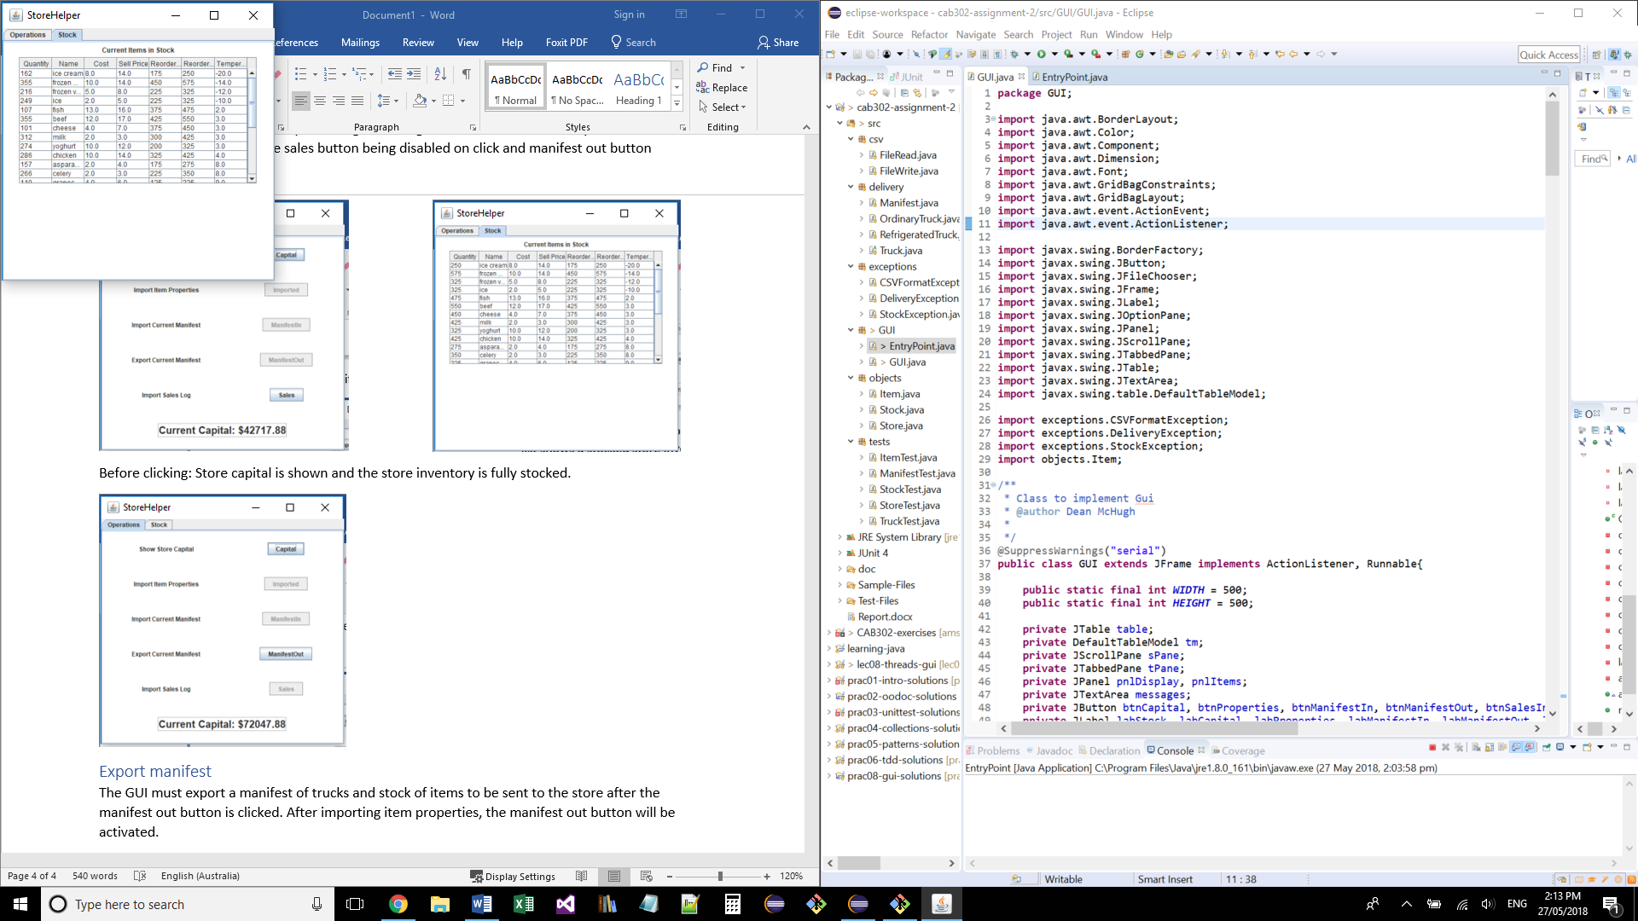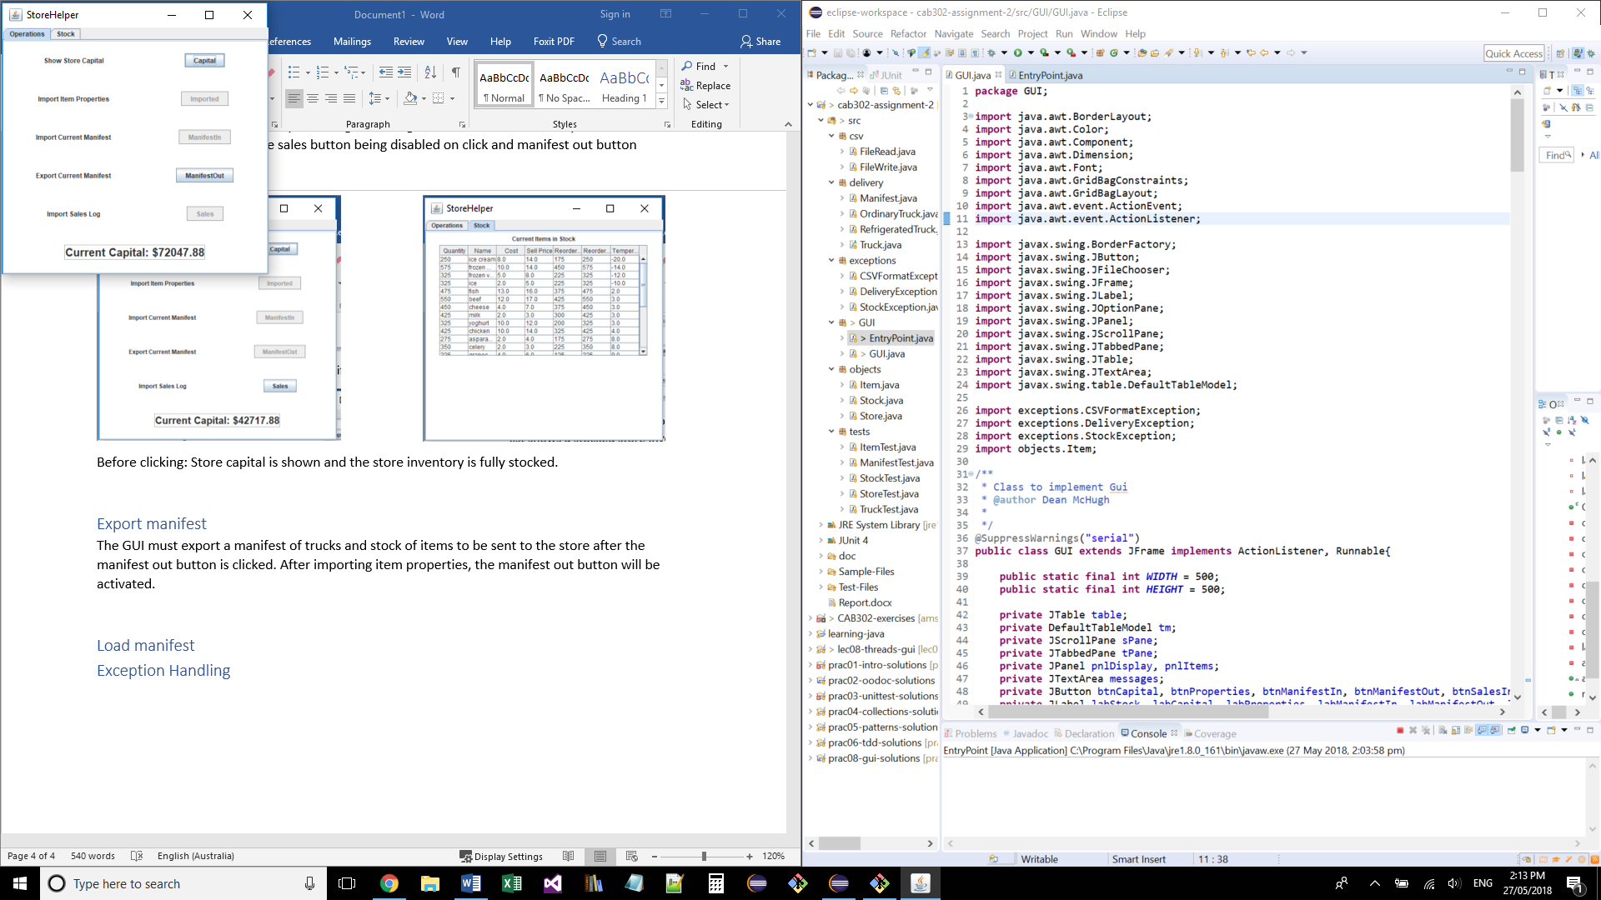

After click: Sales button disables and manifest out button enabled. The store capital increases to show returns and stock list is reduced.

## Export manifest

The GUI must export a manifest of trucks and stock of items to be sent to the store after the manifest out button is clicked. Clicking the manifest out button will disable the button and enable the manifest in button.

This function was tested by observing the store capital before and after exporting manifest. The stock and store capital will not change from clicking the button. The button observed to be disabled after clicking and the manifest in button activated.

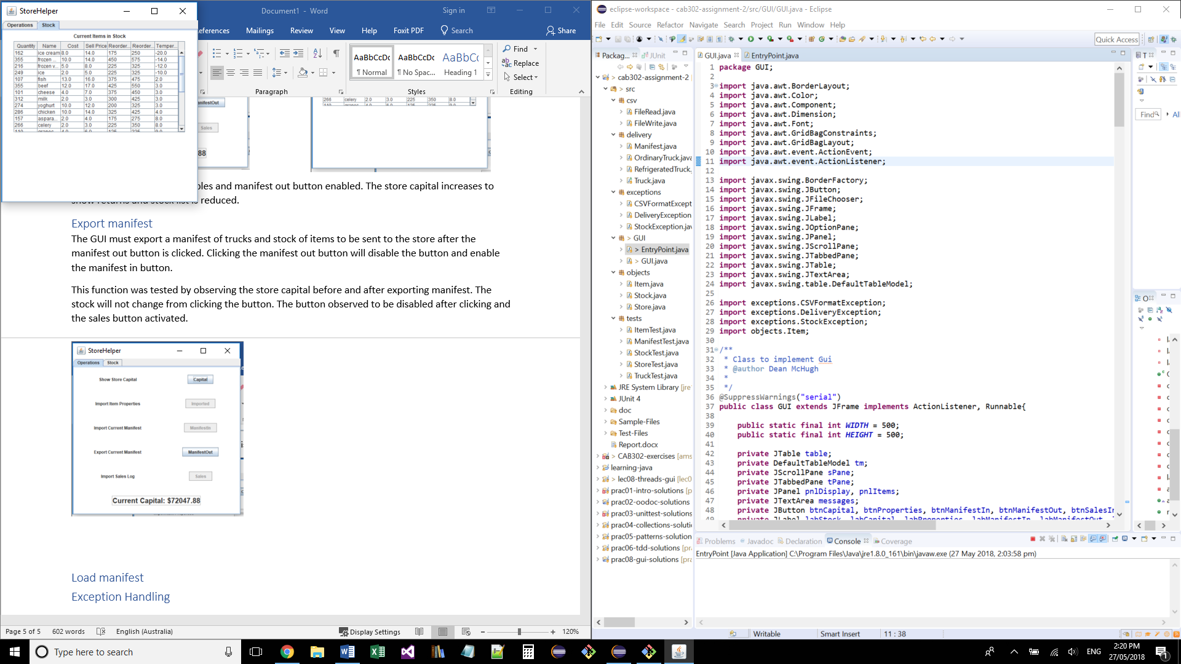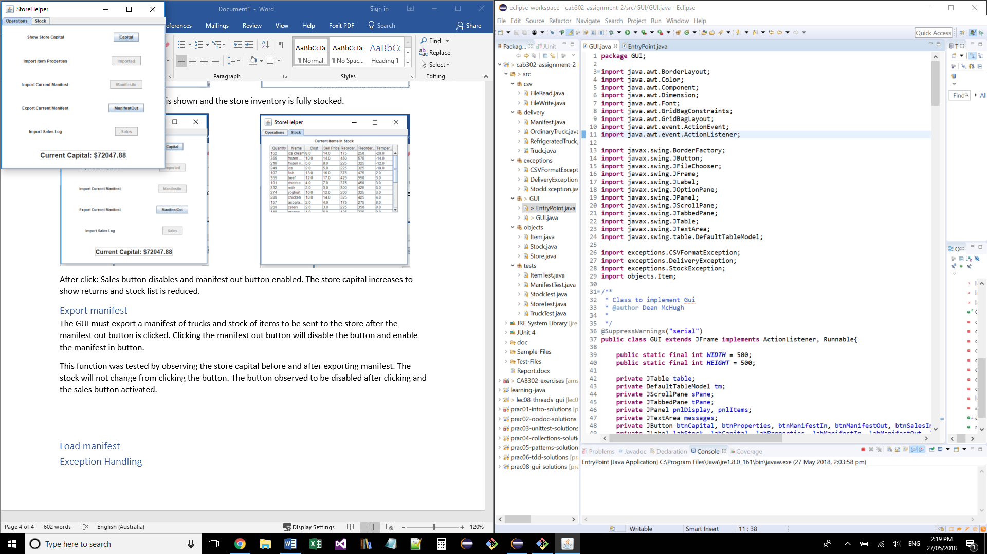

Before click: Current store capital shown before exporting manifest. The manifest out button is active and the stock list shows after sales.

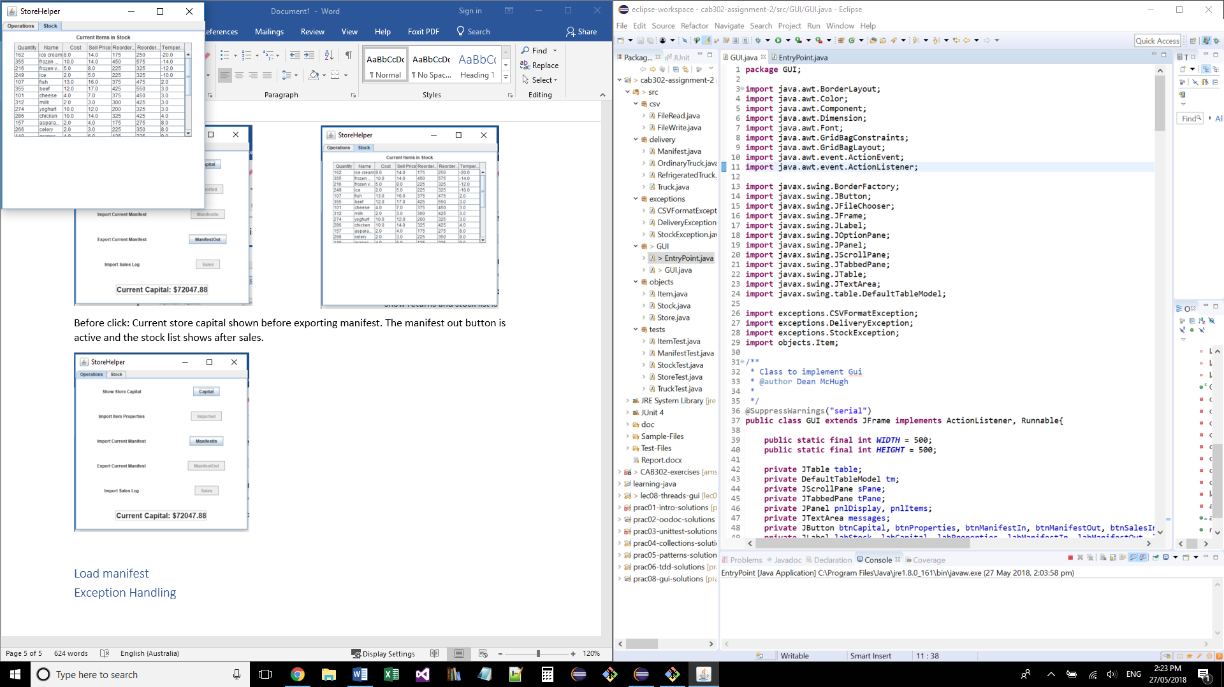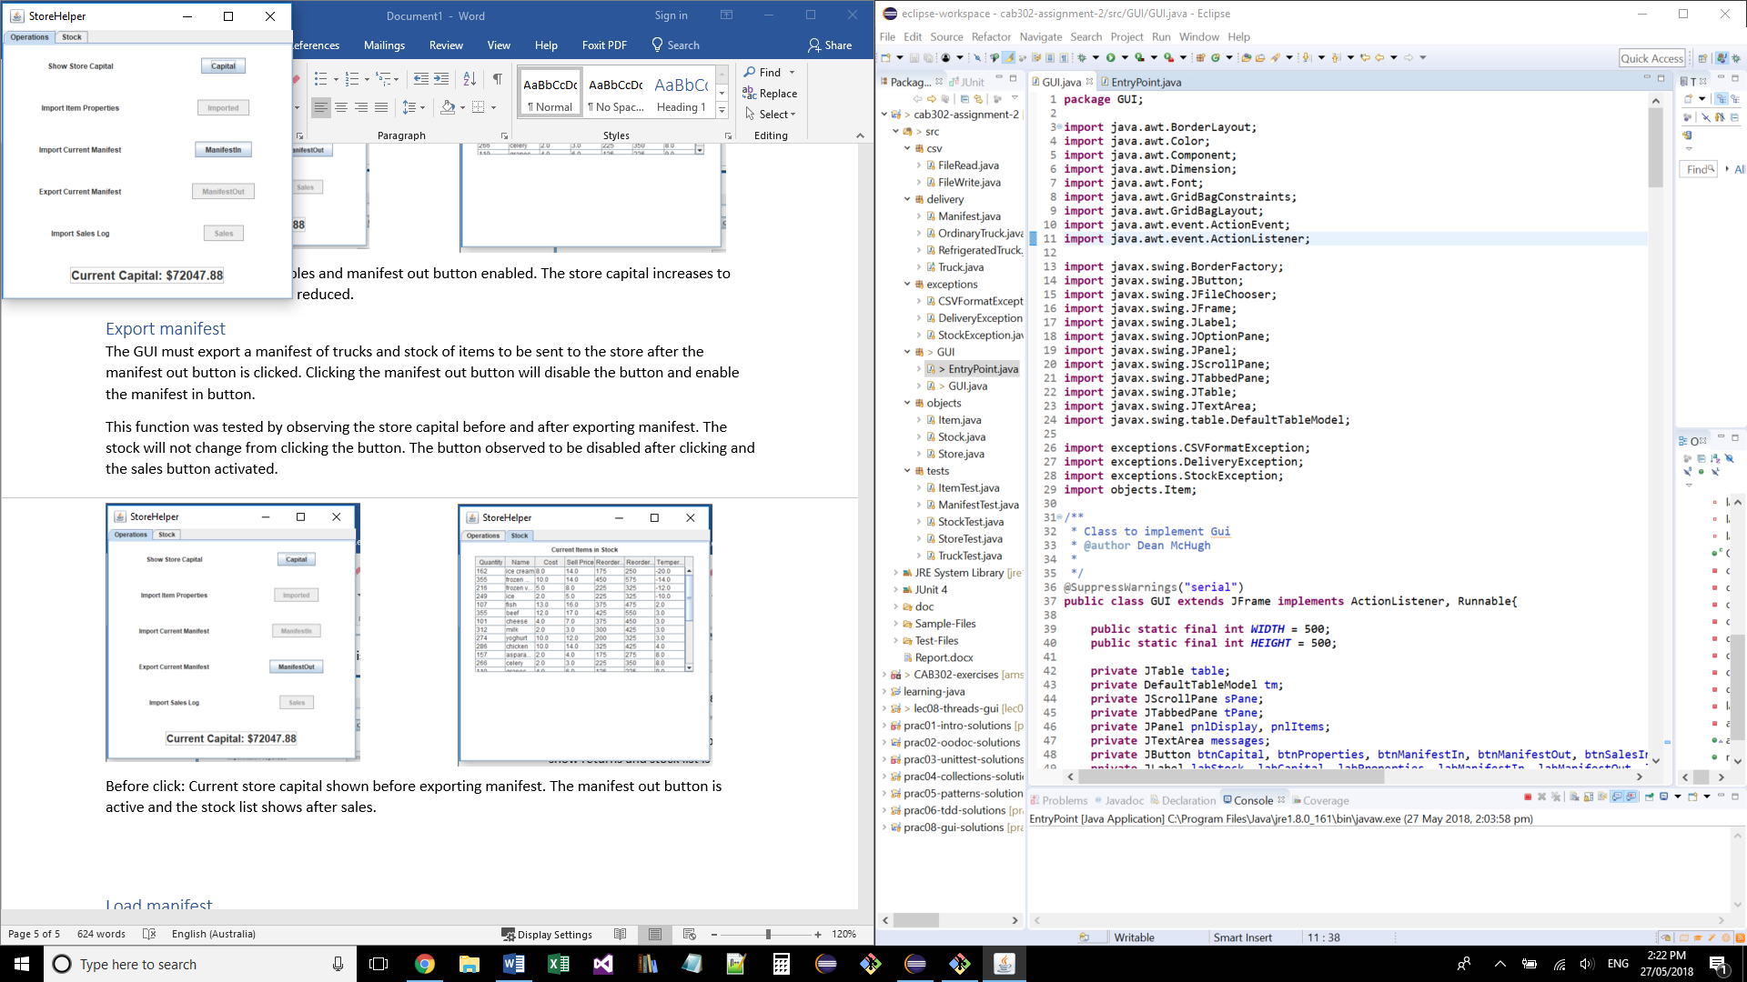

After click: Current store capital and store inventory have not changed. The manifest out button have been disabled and manifest in button enabled.

## Load manifest

The GUI must import the manifest of items from the delivery. This will lower the store capital and increase the store item quantity. Clicking the manifest in button will disable the button and enable the sales button.

This function was tested but observing the decrease in store capital and increase in stock item quantity if item reached reorder point.

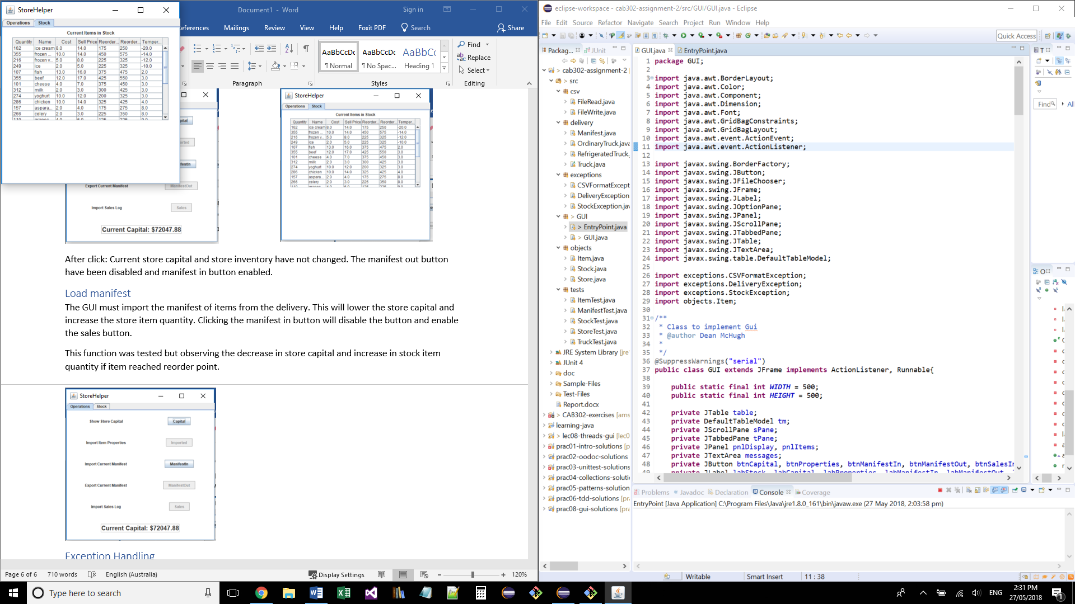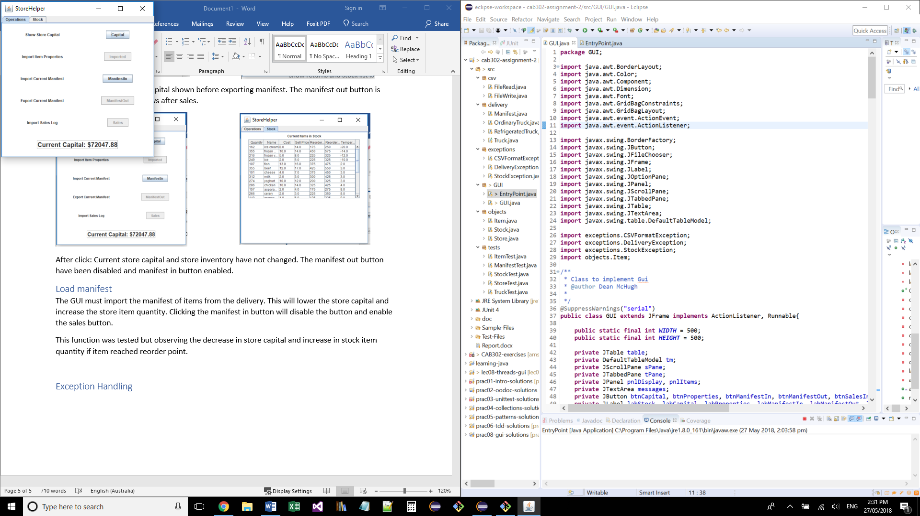

Before click: current store capital is shown. The manifest in button is active and stock list has not changed.

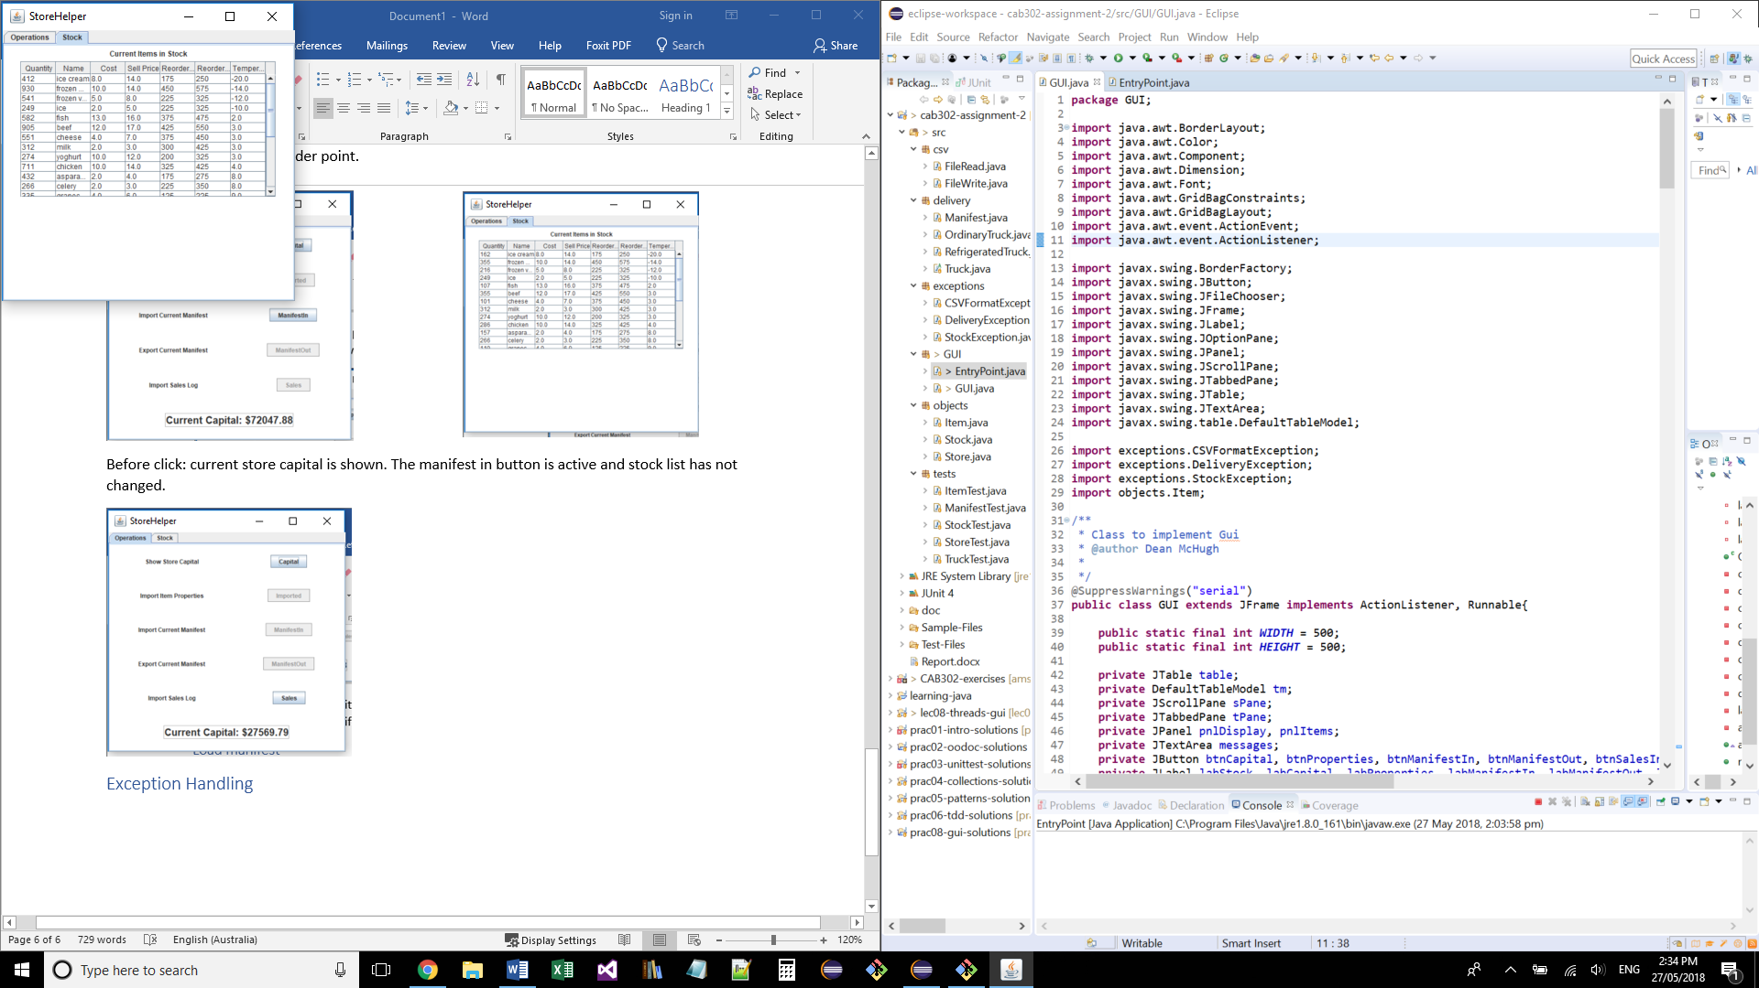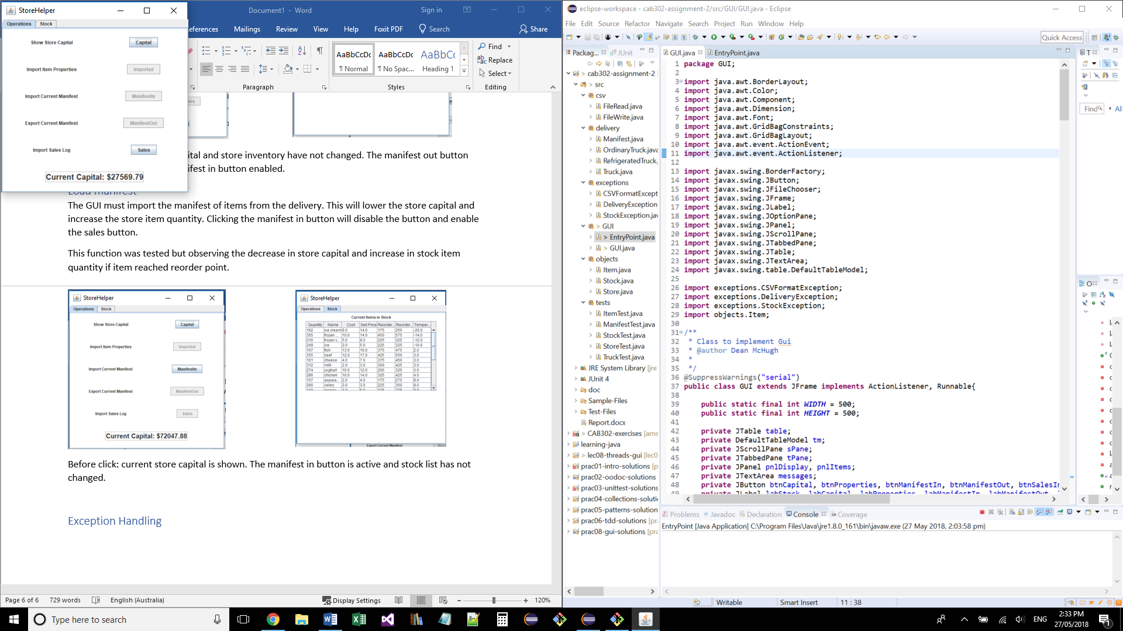

After click: Current store capital had decreased from cost of items. The manifest in button is disabled and the sales button is enabled. Stock list item quantity has increased.

## Exception Handling

The GUI interface is expected to show exceptions thrown from the back-end code by showing message boxes to the user.

This was tested by triggering exceptions and making the message box with exception type show.

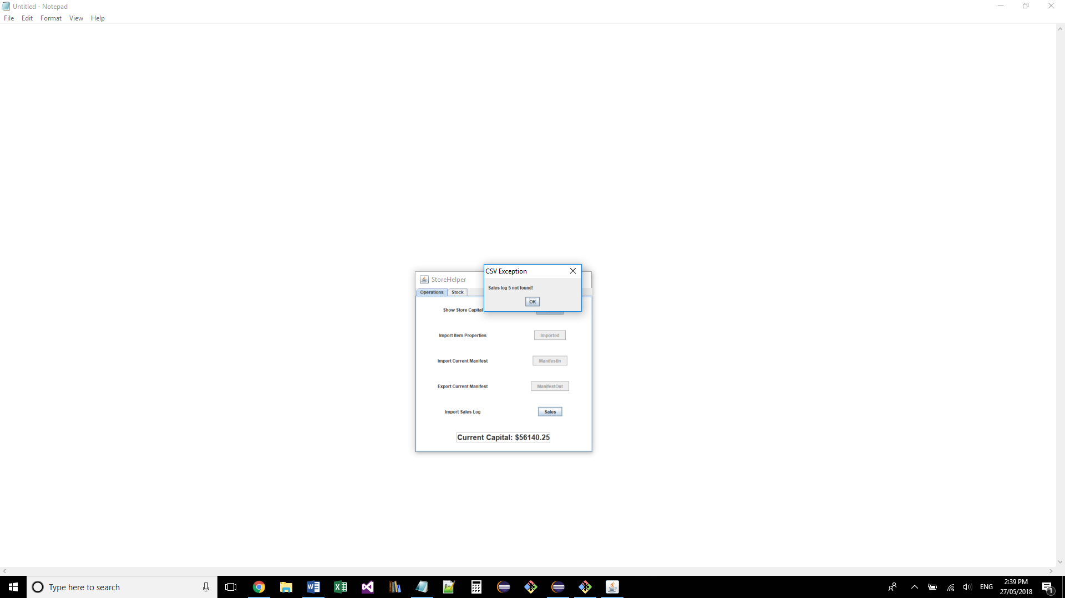

The CSV exception has been triggered and the message box has shown appeared to tell the user.